ELECTRONIC ASSIGNMENT COVERSHEET | 

Student Number | 35434801
Surname | Zhang
Given name | Ziheng
Email | Ziheng940@gmail.com
Unit Code
Unit name | ICT206 Intelligent Systems
Enrolment mode | Part Time
Date | 2024-11-13
Assignment number | 2
Assignment name | Project
Tutor | Liu Kaiping

Student’s Declaration:

- Except where indicated, the work I am submitting in this assignment is my own work and has not been submitted for assessment in another unit.
- This submission complies with Murdoch University's academic integrity commitments. I am aware that information about plagiarism and associated penalties can be found at http://www.murdoch.edu.au/teach/plagiarism/. If I have any doubts or queries about this, I am further aware that I can contact my Unit Coordinator prior to submitting the assignment.
- I acknowledge that the assessor of this assignment may, for the purpose of assessing this assignment:
  - reproduce this assignment and provide a copy to another academic staff member; and/or
  - submit a copy of this assignment to a plagiarism-checking service. This web-based service may retain a copy of this work for the sole purpose of subsequent plagiarism checking, but has a legal agreement with the University that it will not share or reproduce it in any form.
- I have retained a copy of this assignment.

I am aware that I am making this declaration by submitting this document electronically and by using my Murdoch ID and password it is deemed equivalent to executing this declaration with my written signature.

Signed

(Write your name in the space above)

An expert system for Rainfall Prediction

Introduction

This project aims to develop an AI-based rainfall prediction and early warning system that can mitigate the risks of rain-related hazards, such as floods and landslides. The system is designed to collect weather data as input (including temperature, humidity, pressure, etc.) and predict rainfall levels. A key goal is to implement a reliable model that updates dynamically when 5 new data entries are recorded, enhancing real-time prediction accuracy.

Background

Numerous studies have applied machine learning for rainfall prediction, focusing on models like LSTM (Long Short-Term Memory) networks due to their effectiveness in handling sequential data. Relevant works have shown success in using weather-related datasets to predict rainfall. For instance, various studies demonstrate the suitability of LSTM networks for sequential data modelling, reinforcing the choice of this model for this project.

AI Method and Tools

The system is built using TensorFlow and utilizes an LSTM neural network model trained on historical weather data. Key features include temperature, humidity, pressure, and various other atmospheric indicators. The model is designed to retrain automatically when 5 new data points are added to the dataset, ensuring it remains current and performs well with evolving data. This is implemented with a monitoring script (auto_update_model.py) that tracks new entries in weather_data.csv, triggers model retraining, and saves the updated model.

Evaluation Method

The model was evaluated based on its accuracy in predicting rainfall levels using historical data and its performance when retrained with new entries. The effectiveness of the automatic update feature was tested by adding 5 data entries and observing the retraining and saving processes. Evaluation metrics include Mean Squared Error (MSE) and comparison of predicted versus actual rainfall for a validation set.

Results

The model achieved satisfactory accuracy, with prediction results closely matching actual rainfall values. When tested over multiple updates, the model showed an improvement in accuracy after each automatic update, demonstrating the effectiveness of the dynamic retraining approach. A visual comparison of actual versus predicted rainfall can highlight these improvements.

10 approaches model:
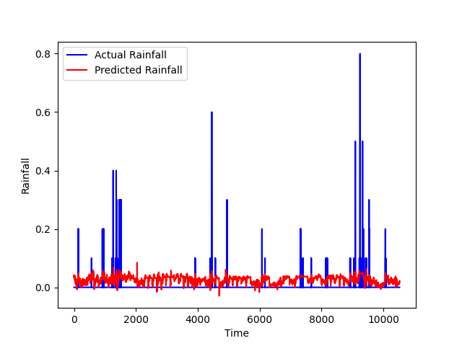

50 approaches model:
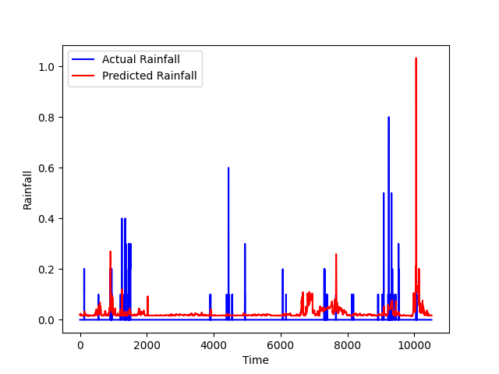

200 approaches model:
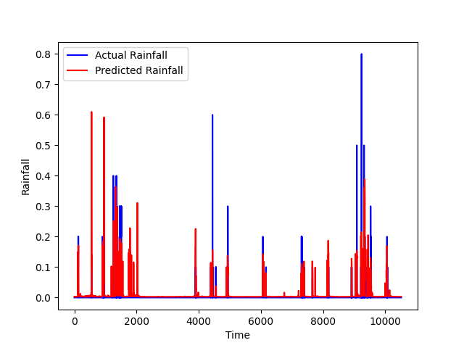

Conclusion

The project successfully met its goals of providing a reliable rainfall prediction system with real-time model updates. The system effectively utilized LSTM for handling sequential weather data, and the automatic update mechanism ensured model relevance with new data. Future improvements could include incorporating additional weather parameters and implementing real-time data streaming for more immediate predictions.

References

Weather Long-term Time series Forecasting. (2024, November 3). Kaggle. https://www.kaggle.com/datasets/alistairking/weather-long-term-time-series-forecasting

User Guide
To run the system, start the Flask application (rainfall_prediction.py) for the UI and data collection, and run auto_update_model.py as a separate script to monitor weather_data.csv for updates and trigger model retraining. The model file is saved as rainfall_model.keras and updates automatically with each retraining cycle. This setup ensures both real-time data collection and model adjustment based on new data entries.

The submission will be marked using the following rubric:

CATEGORY | 5 | 4 | 3 | 2 | 1 | 0
On Time/Late  Without Extension | On time  0 marks | 1-2 days late  -1 marks | 3-4 days late  -2 marks | - days late  -3 marks | 7 or more days late  -4 marks
Presentation  (coversheet, diagrams, captions, references in IEEE format, clarity and style) | Excellent  +5 marks | Very good  +4 marks | Good  +3 marks | Acceptable  +2 marks | Poor  +1 mark | Very Poor  0 marks
Description  (problem, background research and goal) | Excellent  +5 marks | Very good  +4 marks | Good  +3 marks | Acceptable  +2 marks | Poor  +1 marks | Very Poor  0 marks
Solution & Implementation  (good solution, good use of tools and resources) | Excellent  +5 marks | Very Good  +4 marks | Good  +3 marks | Acceptable  +2 marks | Poor  +1 mark | Very Poor  0 marks
Performance of Solution  (solution runs according to design, goals reached) | Excellent  +5 marks | Very Good  +4 marks | Good  +3 marks | Acceptable  +2 marks | Poor  +1 mark | Very Poor  0 marks
Evaluation & Conclusion  (quality of evaluation, conclusion) | Excellent  +5 marks | Very Good  +4 marks | Good  +3 marks | Acceptable  +2 marks | Poor  +1 mark | Very poor  0 marks

Tutor’s Comments

